| **PROJECT REPORT** |
| --- |

# 

# **1) INTRODUCTION :-**

a)OVERVIEW:-

Thyroid disease is the general concept for a medical problem that prevents one’s thyroid from producing enough hormones .

Thyroid disease can affect everyone - men,women,children,adolescents,and the elderly.

Thyroid disorders are detected by blood tests, which are notoriously difficult to interpret due to the enormous amount of data necessary to forecast results.

For this reason,this study compares eleven machine learning algorithms to determine which one produces best accuracy for predicting thyroid risk accurately.

Problems can occasionally occur in the gland. One of the most common problems affecting the thyroid gland is [hypothyroidism](https://www.mayoclinic.org/diseases-conditions/hypothyroidism/symptoms-causes/syc-20350284) . This occurs when the gland stops making enough hormone. The most common cause of this condition is Hashimoto’s thyroiditis - an autoimmune disorder that ultimately causes the gland to stop working.Symptoms of hypothyroidism may vary, and can include fatigue, weight gain, constipation and dry skin. Hypothyroidism is treated medically by replacing the body’s hormone with a medication that is taken daily for life.

b)PURPOSE:-

The purpose of this project is to decide the type of “medicine” or “drug” which should be given to the patient suffering from thyroid depending upon their respective “blood pressure(BP)”, “Cholesterol” and “Na_to_K” levels.

This project is just a try to reduce the thyroid illness.

The person must give the exact values in required fields for accurate prediction .

In this project we have used a dataset based on the list of drugs.

T4(tetraiodothyronine or thyroxine) and T3(triiodothyroxine) are thyroid hormones that help regulate metabolism.

Thyrotropin is responsible for the regulation of these two thyroid hormones.

All kinds of hyperthyroidism are caused by an excess of these hormones.

Other illnesses, such as serious diseases , can be attributed to excessive hormone production.

# **2) LITERATURE SURVEY :-**

a) Existing Problem:-

There are few things you can do to help reduce your chances of developing thyroid disease.

Ask for a thyroid collar when you get an X-ray, avoid smoking, and limit your intake of soy.

You can also try to avoid potential environmental contaminants.

Finally, make sure to see your primary care doctor every year.

There are no guarantees you won’t develop thyroid disease, and a family history of auto-immune thyroid conditionals can put you at higher risk.

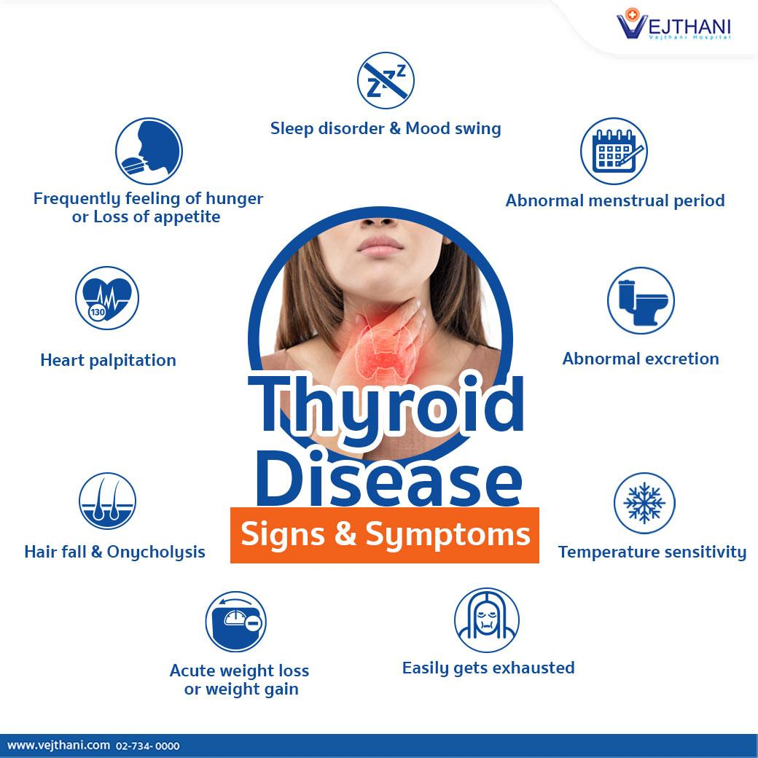

b)Proposing Solution:-

It’s good to take preventative measures when it comes to your thyroid.

This can help lessen your risk of problems.

If you are at risk of thyroid disease, it’s important to be proactive in noticing any early symptoms so you can get treatment as early as possible if you need it.

One could go for total thyroidectomy for Graves’ hyperthyroidism.

Hypothyroidism is an underactive thyroid. This has no cure.

But treatment can ease most or all symptoms.Treatment is done with daily thyroid hormone pills.

These pills replace the hormone your thyroid doesn’t make.

You'll likely need to take a daily pill for the rest of your life.

Your healthcare provider will change your dose to reach the right hormone levels.

Take the thyroid hormone pill on an empty stomach. Take it without other medicines.

And take it at the same time each day. This is to make sure it works as it should.

Over time, your dose may be changed.

The medicine has few side effects if the dose is right for you. But if the dose is too high, you may have symptoms of an overactive thyroid.

# **3) THEORITICAL ANALYSIS :-**

a)Block Diagram:-

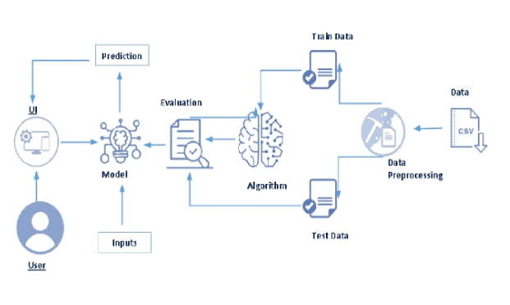

b)Hardware/Software Designing Requirement:-

A normal PC system or laptop could be used as hardware and makesure that they are atleast windows 6,7,8,9 or 10 with 4GB RAM , 256 hard disk.

Anaconda navigator,python or spyder ; any of them could be used to run “app.py” after building the application.

Skills required are Python, Python Web Frame, Python for Data Analysis, Python Data Visualization, Exploratory Data Analysis and Data pre-processing techniques.

# **4) EXPERIMENTAL INVESTIGATIONS :-**

Thyroid tests will tell your healthcare provider how well your thyroid gland works.

These tests can help diagnose conditions like hyperthyroidism, hypothyroidism,

Graves’ disease, Hashimoto’s disease and thyroid cancer.

Types of thyroid tests include blood tests, imaging tests and nuclear medicine tests.

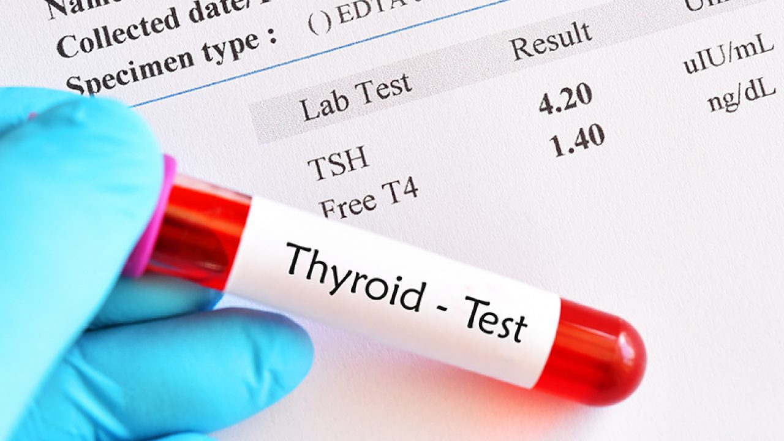

If your TSH level is high, it might mean you have hypothyroidism.

This means your thyroid gland doesn’t make enough thyroid hormone.

On the other hand; if your TSH level is low, it indicates you’ve got hyperthyroidism.

In this case, your thyroid gland makes too much thyroid hormone.

Overactive and underactive thyroid can interfere with daily routines and hinder your quality of life.

If you have symptoms of thyroid disease, a thyroid test can find out what’s causing them; so, your provider can recommend you suitable treatment.

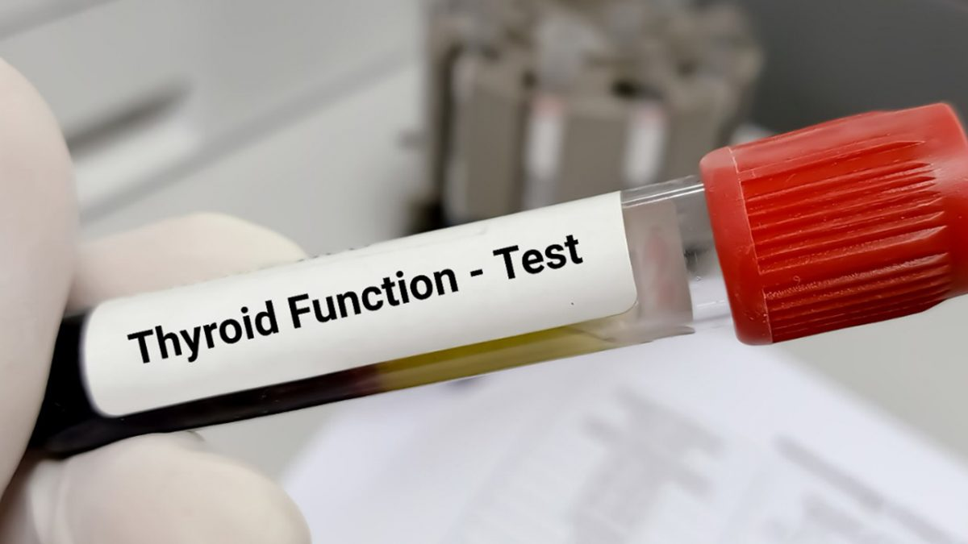

# **5) FLOWCHART :-**

| DATA COLLECTION |
| --- |



| VISUALIZATION &  ANALYZING THE DATA |
| --- |



| DATA PRE-PROCESSING |
| --- |



| SPLIT DATA |
| --- |



| TEST DATA | TRAIN DATA |
| --- | --- |



| FEATURE SELECTION |
| --- |



| MODEL SELECTION |
| --- |



| MODEL EVALUATION |
| --- |



| RESULT PREDICTION |
| --- |

# **6) RESULT :-**

The codes are written perfectly so the project is successful and is running well.

The final output of the project will decide the medicine which should be taken depending on the values of “BP”, “Cholesterol” and “Na_to_K” given.

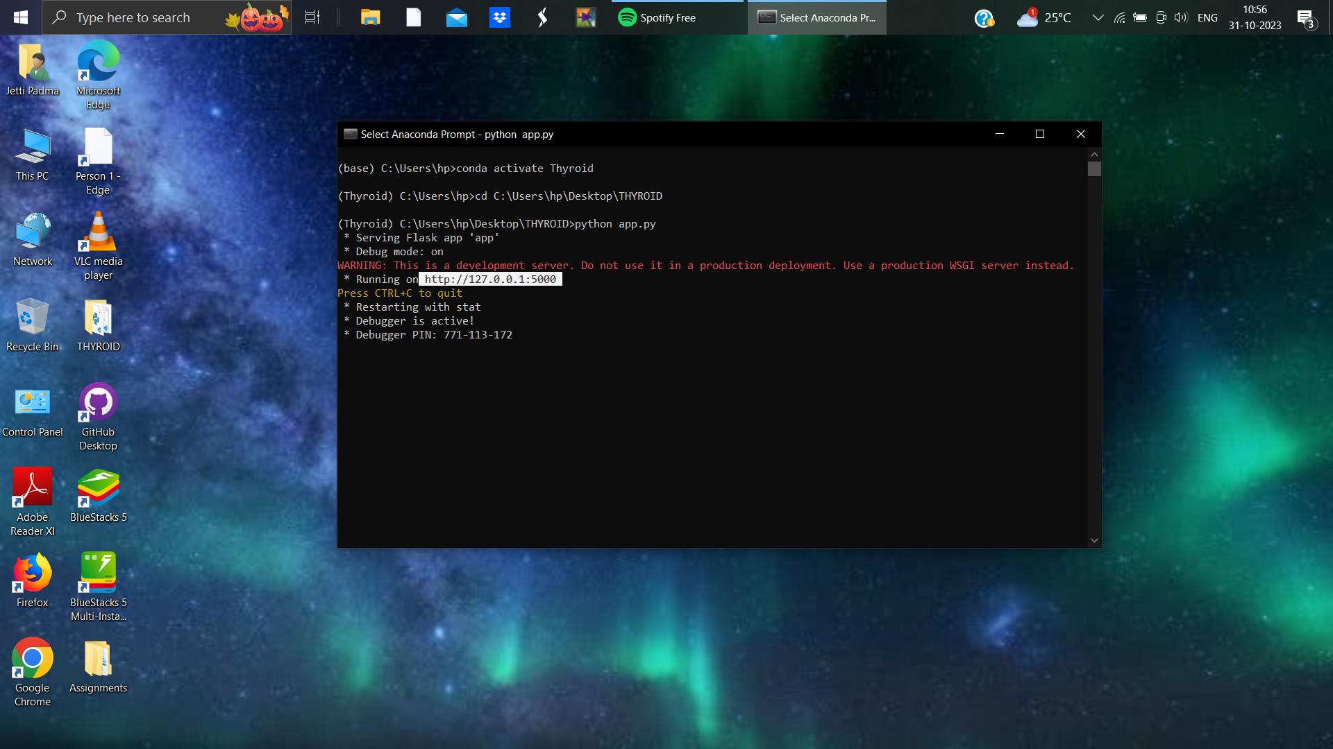

After running the URL in browser the homepage will open up;

press on predict and give the values and click submit for final result.

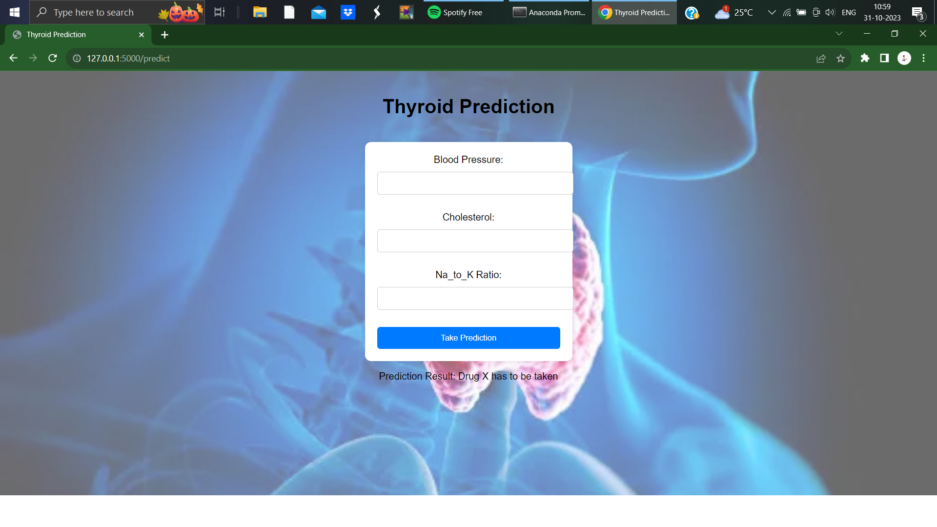

# **7) ADVANTAGES & DIS-ADVANTAGES :-**

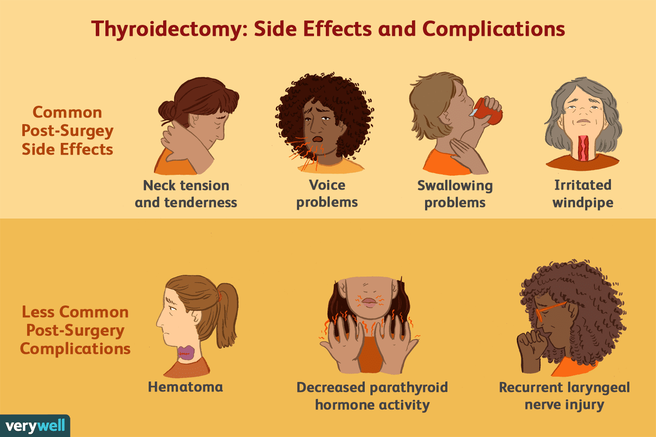

a)ADVANTAGES:-

* No recurrent hyperthyroidism
* No radiation risk
* Rapid control of hyperthyroidism
* No reported detrimental effect on the course of Graves’ orbitopathy

b)DIS-ADVANTAGES:-

* Risk of post-operative hypoparathyroidism
* Risk of recurrent nerve palsy
* Permanent hypothyroidism
* Risks related to anesthesia or surgery
* Costlier
* Hospitalization
* Permanent scar

# **8) APPLICATIONS :-**

* Estimate the likelihood of a better outcome when more data is used; as increasing thyroid prediction accuracy will enhance thyroid problem identification.
* To enhance the models performance , a variety of pre-processing techniques like identifying and handling the missing values, encoding the categorical data, etc; are applied.
* To evaluate the effectiveness of the employed machine learning algorithms, the accuracy, precision, recall and FI-scares are examined.
* The target variable in the thyroid disease dataset is the diagnosis of thyroid disease for each patient.
* The goal of the dataset is to predict the type of medicine the person has to use depending upon the values given.

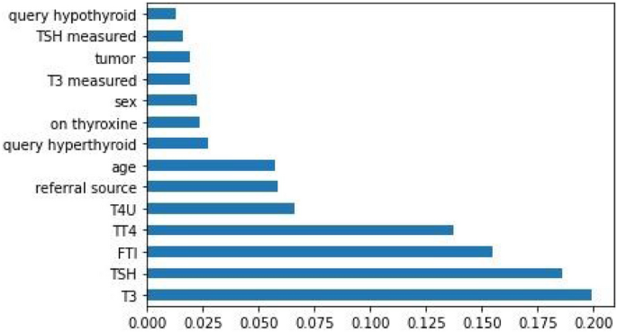

# **9) CONCLUSION :-**

The study presents a thyroid disease prediction approach which utilizes random forest based features to obtain high accuracy.

The approach can obtain a 0.99 accuracy to predict ten thyroid diseases.

For the most part, the emphasis is placed on the optimization of machine learning and deep learning models and the feature selection part is under-studied or completely ignored for a thyroid disease problem.

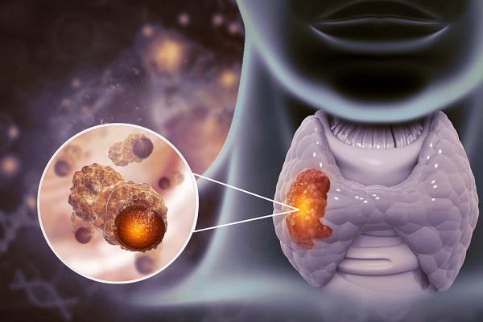

Despite the high accuracy reporting approaches, such approaches are tested on samples under 1000, and results are not validated.

A novel machine learning based thyroid disease prediction approach is proposed that focuses on the multi-class problem.

# **10) FUTURE SCOPE :-**

Over the last decade, surgeons have witnessed dramatic changes in surgical practice as a result of the introduction of new technological advancement.

Some of these changes include refinement of techniques in thyroid cancer surgery.

The development of various endoscopic thyroidectomy techniques, the addition of the da Vinci robot, and the use of operative adjuncts in thyroid surgery, such as intraoperative neuromonitoring and quick intraoperative parathyroid hormone, have made thyroid cancer not only safer and better accepted by patients with thyroid cancer but also offer them more surgical treatment options.

Thyroid Research encompasses a wide range of thyroidology topics including, diagnosis, pharmacological and other treatment methods, invasive treatment, physiological mechanisms of thyroid hormone action and regulation, immunological aspects, genetics, new guidelines in disease management, thyroid related diseases and complications.

There is no cure for hypothyroidism. Treatment requires lifelong medication and lifestyle modifications. The prognosis for hypothyroidism is generally good when medication is started early. However, your proper dosage may take some time to figure out, and the dosage may need to be adjusted over time.

If untreated, hypothyroidism carries a high [morbidity (illness) and mortality](https://www.verywellhealth.com/what-is-morbidity-2223380) rate. Untreated hypothyroidism carries an increased risk of medical complications such as intellectual disability, depression, and myxedema coma (coma with low body temperature). Hypothyroidism may induce or exacerbate cardiovascular problems.

With proper treatment, a person with hypothyroidism usually has a normal life expectancy, with little or no decrease in quality of life.Hypothyroidism generally carries a greater life expectancy than hyperthyroidism (overactive thyroid).

# **11) BIBLIOGRAPHY :-**

For completion of project the reference was taken from the GitHub repositories of the mentors,

because the mentors used to save the topics taught in their respective repositories and if any doubt would arise for us we could simply view their repositories which were provided in the WhatsApp group and select the particular topic which we have doubts about.

GitHub repositories of the mentors :-

* <https://github.com/HariPrabu741/APSCHE-AI-ML>
* <https://github.com/SaumyaMohandas/Apschesep_AIML>

Also we have watched the recorded sessions to get a better understanding.

Recorded Sessions Link :- <https://apsche-vip.teachable.com/purchase?product_id=5015540>

The following are the datasets used for the project and assignments.

Dataset Used for Project :- <https://www.kaggle.com/prathamtripathi/drug-classification>

Datasets Used for Assignments :-

* <https://www.kaggle.com/datasets/mexwell/us-school-scores>
* <https://www.kaggle.com/datasets/shree1992/housedata>
* <https://drive.google.com/file/d/1dV0wuq_VpK0qLyD3L-52NepPq7wsTQNk/view?usp=share_link>

## APPENDIX :-

The code for the solution built is a python source file with the name “app” and it could be run on anaconda prompt or VSCode as “app.py”.

Source Code :-

from flask import Flask, render_template, request

import pickle

import numpy as np

import pickle

import pandas as pd

app = Flask(__name__)

# Load the pre-trained model from the pickle file

model=pickle.load(open(r"thyroid_1_model.pkl",'rb'))

le5=pickle.load(open(r"label_encoder.pkl",'rb'))

@app.route('/')

def home():

return render_template('home.html')

@app.route('/predict', methods=['GET', 'POST'])

def predict():

if request.method == 'POST':

bp = float(request.form['bp'])

cholesterol = float(request.form['cholesterol'])

na_to_k = float(request.form['na_to_k'])

# Prepare input data for prediction

input_data = [[bp, cholesterol, na_to_k]]

# Make a prediction using the loaded model

prediction = model.predict(input_data)

prediction=le5.inverse_transform(prediction)

print(prediction)

if(prediction==0):

prediction = "Drug Y has to be taken"

elif(prediction==1):

prediction = "Drug A has to be taken"

elif(prediction==2):

prediction = "Drug B has to be taken"

elif(prediction==3):

prediction = "Drug C has to be taken"

else:

prediction = "Drug X has to be taken"

return render_template('prediction.html', result=prediction)

return render_template('prediction.html')

if __name__ == '__main__':

app.run(debug=True)